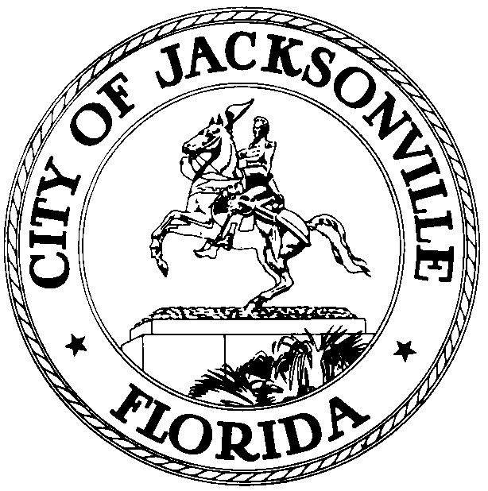
Task Force on Consolidated Government
Jacksonville City Council
Council Member Lori Boyer, Chair

May 15, 2014

Meeting Schedule

9:00-9:15 Welcome & Establish Quorum
Lori Boyer, Chair

9:15-9:45 Review of Undecided Organization & Governance Committee Recommendations
Damian Cook, Task Force Administrator
- Budget – Zero-based Budgeting
- City Council – Start date for Council President’s term
- Mayor – Required time period to fill CAO & dept. head vacancies
- Independent Authorities – Training for board members
- Independent Authorities – Accountability of board members to the City and the Authority they serve
- City Charter – Requirement that ordinances be included in the published ord. code
- City Charter – Charter amendments approved by referendum may only be waived, amended, or removed by referendum
- Strategic Planning & Integrated Mission (only approved in concept)
9:45-11:45 Review of Neighborhoods & Infrastructure Committee Recommendations
Damian Cook, Task Force Administrator

11:45-12:00 Public Comment

12:00 Adjourn

Next meeting:
Thursday, May 22, 2014, 9 a.m.
Council Chamber, 1st Floor, City Hall

Undecided Issues:
- Capital Improvement Process (will be taken up with Neighborhood’s recs.)
- Budget – Zero-based Budgeting
- City Council – Start date for Council President’s term
- Mayor – Required time period to fill CAO & dept. head vacancies
- Independent Authorities – Training for board members
- Independent Authorities – Accountability of board members to the City and the Authority they serve
- City Charter – Requirement that ordinances be included in the published ord. code
- City Charter – Charter amendments approved by referendum may only be waived, amended, or removed by referendum
- Strategic Planning & Integrated Mission (only approved in concept)
New Issues to Review:
- Taxation and Provision of Services in Municipal Service District 1
- Collective Bargaining Language in Article 19 of the City Charter
- Minority Contracting
Issues Not Completed During Committee Process
- Alternative Revenue Sources/Grants
- Civil Service/High Quality Workforce
- Long-range Planning within the City

